DISCOGRAPHY
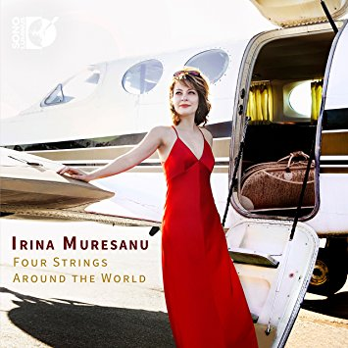
Irina Muresanu: Four Strings Around the World
Irina Muresanu
Sono Luminus
PURCHASE THIS RECORDING FROM
Amazon.com

Lift: Chamber Music by Elena Ruehr
PERFORMED BY
Irina Muresanu (violin), Ethan Filner (viola), Jennifer Kloetzel (cello) Sarah Bob (piano)
PURCHASE THIS RECORDING FROM
AVIE Records
Partita for Solo Violin by Thomas Oboe Lee
Irina Muresanu (Performer)
PURCHASE THIS RECORDING FROM:
Band Camp

A Voice Gone Silent Too Soon: the Music of Gerhard

Walden Chamber Players
CD Baby
PURCHASE THIS RECORDING FROM:
Amazon
Thomas Oboe Lee: Six Concertos
PERFORMED BY
Thomas Oboe Lee (Artist, Composer), Sarah Brady (Artist, Performer), Robert Levin (Artist, Performer), Irina Muresanu (Artist, Performer), Rafael Popper-Keizer (Artist, Performer), Jennifer Slowik (Artist, Performer), Ina Zdorovetchi (Artist, Performer)
BMOP/sound
PURCHASE THIS RECORDING FROM:
Amazon
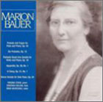
Music of Marion Bauer
Eskin (Artist), Boldin (Artist), Muresanu (Artist), Bauer (Composer)
Albany Records
PURCHASE THIS RECORDING FROM:
Amazon
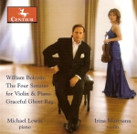
William Bolcom: The Four Sonatas for Violin and Piano
Irina Muresanu, violin; Michael Lewin, piano.
Centaur Records [product id: CRC2910]
PURCHASE THIS RECORDING FROM:
iTunes
Sonates pour violon
Irina Muresanu, violin, Dana Ciocarlie, piano
AR RE-SE [product id: 2006-0]
WORKS ON THIS ALBUM:
Guillaume Lekeu: Sonata in G for violin and piano
Albéric Magnard: Sonata Op. 13 for violin and piano
Boston Trio – Brahms and Smetana
Boston Trio
parjomusic
PURCHASE THIS RECORDING FROM:
CD Baby
Elegy and Blues
Boston Trio
Centaur
PURCHASE THIS RECORDING FROM:
Naxos Direct

WILLIAM REINERT ASSOCIATES,
646.236.9702 Fax: 775.259.5585
info@williamreinert.com

